

20/03/2019

Alumnos:

Xochitl América Rodríguez Villanueva

César Mondragón Martín

Ángel Modesto Hernandez Méndez

Universidad Autónoma de San Luis Potosí

Facultad de Ingeniería

Ingeniería en Computación e Informática

SCRUM

Tecnología Informática

Semestre 2018-2019/II

# Artículo 1: Implementation of Scrum in the Construction Industry

Available online at www.sciencedirect.com **ScienceDirect**



Procedia Engineering 164 ( 2016 ) 269 – 276

Creative Construction Conference 2016, CCC 2016, 25-28 June 2016

Implementation of Scrum in the Construction Industry

Thomas STREULEa, Nino MISERINIa, Olin BARTLOMÉb, Michael KLIPPELc, Borja GARCÍA DE SOTOd*

*aETH Zurich, Stefano-Franscini-Platz 5, Zurich, 8093, Switzerland bSWISS PROPERTY AG, Pelikanstrasse 18, Zurich, 8001, Switzerland*

*cInstitute of Structural Engineering, ETH Zurich, Stefano-Franscini-Platz 5, Zurich, 8093, Switzerland*

*dInstitute of Construction and Infrastructure Management, ETH Zurich, Stefano-Franscini-Platz 5, Zurich, 8093, Switzerland*

# Abstract

The way in which construction projects are managed has not changed significantly in the last decades; however, stakeholders, materials, competition, and user requirements are continuously changing. This creates a gap between the current managerial view on how construction projects are conducted and how they could be managed to increase efficiency.

The construction industry could use new frameworks for action in the project and product management, and learn from the experiences of other industries. With this background in mind, some construction companies are enhancing the performance of their project teams to improve their competitiveness and increase the added value to their clients and themselves.

This paper investigates the implementation of a framework from the IT sector into the construction industry: Scrum. Conducting a case study, the implementation and application of Scrum was analysed through the evaluation of its different artifacts. This research covers the following questions: Can Scrum be implemented in the design phase of the construction industry? What adaptations are needed to use Scrum to improve the design phase of construction projects? How and where could Scrum, or parts of it, be used by the design and planning departments of construction companies?

The results from this study show that Scrum has great potential in the design and planning departments of construction firms. From the analysis of the applications of Scrum in the case study, tangible benefits and weaknesses of the implementation, and its different artifacts, were identified. Finally, this paper gives recommendations about the use of Scrum in the design phase and proposes an outlook to implement Scrum in other phases of construction projects.

*Keywords:* Agile; Design Phase; Process Model; Project Management; Scrum

# Introduction

In the construction industry, one of the biggest challenges when creating a building is to account for the unforeseeable [1]. In order to reduce the amount of unforeseeable events, project managers typically use templates, checklists and often models with phases, sub-phases and sub-sub-phases, as indicated for example in [2]. This socalled sequential project management approach aims to plan the project in detail and tries to carry it out without any deviation [3]. The creation of this plan often takes up significant resources before the actual construction has even started. In many cases, these processes are so long that by the time the execution phase has started, the plan needs to be revised because of modified project requirements [4]. Constant modifications of the project requirements coupled with occurring problems in defining the original product requirement causes cost overruns and schedule delay and lowers the product quality. As a countermeasure, agile project management was created [1], whereas agility is defined

* Corresponding author. Tel.: +41-44-633-92-30; fax: +41-44-633-1088. *E-mail address:*garcia.de.soto@ibi.baug.ethz.ch

1877-7058 © 2016 The Authors. Published by Elsevier Ltd. This is an open access article under the CC BY-NC-ND license (http://creativecommons.org/licenses/by-nc-nd/4.0/).

Peer-review under responsibility of the organizing committee of the Creative Construction Conference 2016 doi: 10.1016/j.proeng.2016.11.619

as *“…the ability to both create and respond to change in order to profit in a turbulent business environment”* [5]. Instead of trying to predict unforeseeable risks, one should approach them as opportunities to profit. Therefore, the agile approach is advantageous to the traditional one, as resource consuming detailed planning from the start of the project is avoided. At the same time, decisions are delayed as long as possible [3, 5].

Scrum is one of many agile project management methods. It was created by Sutherland and Schwaber between 1993 and 1995 [6] and their work strongly influenced the Agile Manifesto [7], which sets twelve principles and four key values for all agile project management methods. Similarly, the work by Sutherland and Schwaber was heavily influenced by Nonaka and Takeuschi [8]. In fact, [8] was one of the main foundations for the lean concept. Therefore, it is important to make the differentiation between lean and agile [9]: “*Lean manufacturing* [was developed as] *a response to competitive pressures with limited resources. Agile manufacturing, on the other hand, is a response to complexity brought about by constant change. Lean is a collection of operational techniques focused on productive use of resources. Agility is an overall strategy focused on thriving in an unpredictable environment.* […] *Flexible manufacturing system* [offers] *reactive adaption, while* [agile system offers] *proactive adaption.*”

In this paper, section 2 explains the basics of Scrum before the case study is then presented in Section 3 and the implementation in Section 4. The results are presented in Section 5, and Section 6 concludes this paper and gives an outlook for the implementation of Scrum in the construction industry.

# Scrum – An agile project management method

Scrum is a framework for product development where different processes and techniques can be applied to complex projects. A typical Scrum framework is shown in Figure 1. The Scrum framework consists of the Scrum Roles, the Scrum Artifacts and the Scrum Events [10], which are all explained in the following sections. The expression Scrum is a move from Rugby, where a detailed position, with a clear purpose is needed to achieve a common goal [6].

**Scrum Events**

**Scrum**

**Artifacts**

**Scrum Roles**

Idea

Product Backlog

Sprint Backlog

Sprint

done

?

yes

no

All Items

done?

yes

Increment

no

End

Kick

-

Off

Sprint Planning

Daily Scrum

Sprint Review

Sprint

Retrospective

Hand over

Client

Product Owner

Scrum Master

Product Owner

Development Team

Scrum Master

Development Team

Scrum Master

Development Team

Figure 1: Typical Scrum Framework

## Scrum Roles

The *Scrum Team* consists of the Product Owner, the Development Team and the Scrum Master. The team is selforganised and cross-functional. All decisions of the project are taken within this entity and they have all the competencies needed for the project – there are no advisors to the Scrum Team. The management’s sole purpose is to assist and support the Scrum Team to the best of their abilities so that the Scrum Team achieves their goal [10]. The size of the team varies depending on the area of operations, but a size of seven (± two) members has proven to be successful [6].

The *Product Owner* is responsible for maximizing the value of the project and is the sole representation of the client. He is in charge of creating, updating, and prioritizing the Product Backlog Items (PBIs; Section 2.2). In addition, other responsibilities include optimizing the work performance of the Development Team, to ensure that the PBIs are clear, transparent and understood by everyone [10] The Product Owner also takes into account other stakeholders interests and is the only one who can make changes to the PBIs [10].

The individuals that do the actual work are in the *Development Team*. The members of this team are all equal (no project manager) and although each and everyone has their field of expertise, the team is hold accountable as a whole. The *Scrum Master* ensures that everyone in the Scrum Team understands what is meant by Scrum. The Scrum Master simply enforces the framework given by Scrum and the changes made considering new information. Additionally, the Scrum Master sets all the Scrum Events (Section 2.3) and explains to individuals outside the Scrum Team how they can (or cannot) interact with the Scrum Team. One of the main task of the Scrum Master is to remove any obstacles brought to the Scrum Team so that the Development Team can focus on their work and are not slowed down by insignificant things [10].

## Scrum Artifacts

The Scrum Artifacts can be described as elements with a certain definition in the Scrum framework [6, 10] and are explained below.

The *Product Backlog* is a prioritised list of different Items (e.g. creating floor plans, defining the fire protection concept, designing load bearing elements). Each Item is divided into Tasks and represents a simple and detailed description of what needs to be done by the Development Team. A task is a work package addressed by one or more members of the Development Team and ideally can be completed during one or two days.

The *Sprint Backlog* contains a number of Items which are selected by the Product Owner and the Development Team from the Product Backlog. This list (i.e. Sprint Backlog) contains the Items that the Development Team believes can reach the *state of done* during a Sprint (Section 2.3).

The entity of the Scrum Team defines a *state of done*. When an Item from the Sprint Backlog is considered as done, it is removed from the Sprint Backlog and is then part of the *Increment*. Therefore, the Increment is the sum of all Items considered done.

To be able to estimate how many Items from the Product Backlog can be worked off within a Sprint, Scrum suggests the use of *Planning Poker*, by which each member of the Development Team receives several cards with the numbers zero, one, two, three, five, eight, thirteen, and so on (following the Fibonacci sequence) that will be used to estimate the amount of work needed for a certain Item to reach the state of done by the end of the upcoming sprint. That includes for example that an architect makes an assumption for the water sewage system even it is not his/her field of expertise. If the returned card have numbers further than three numbers apart in the Fibonacci sequence, the people with the highest and lowest number must explain why they picked their number and the game is repeated until all the cards are within a range of three numbers in the sequence. The average is then used as an estimation of the effort for a given Item [11]. Throughout Scrum the Development Team estimates the amount of needed work using points instead of time (e.g., man-hours). This is done because [6] suggests that Gantt-Charts are never accurate and therefore there is no point in trying to assume a number of hours for a task if it is not going to be met. For example, these points merely stipulate that an Item with an eight is more work than an Item with a three or five. However, this information could be used at a later time by the Product Owner to estimate project durations (i.e. completion dates).

## Scrum Events

This Section describes the different events in which the Scrum Team can uphold to the key factors of Scrum: transparency, inspection, and adaption [10].

Like in any other project a *Kick-Off* meeting is held – based on the client’s demands – and the Product Owner creates the Product Backlog to fulfil this demand.

The *Sprint Planning* has a maximum duration of eight hours for a Sprint of a month (proportionally smaller for a shorter Sprint) [10]. During this Sprint Planning, the Development Team guesses the amount of work for the most important Items of the Product Backlog with Planning Poker. After that, the Development Team chooses the Items they think can be done in the Sprint, starting with the most important one; this list is called the *Sprint Backlog* (see also Section 2.2). While considering all the Items from the Sprint Backlog, a bigger goal – the Sprint goal – must be defined. This enables the Development Team to always ask (inspect) themselves: Is this work I am currently doing really necessary for this Sprint (in order to reach the goal)?

When the Sprint Planning is done, the Development Team can start working on the Items during the Sprint. The *Sprint* is a fixed timeframe in which the Development Team aims to reach the state of done for each Item. During the Sprint no changes are permitted to the Items, unless the value or the scope of the Items – with consultation of the Product Owner – is increased. By the end of the Sprint, the Items that cannot be considered as done are moved back to the Product Backlog and will be re-evaluated in the next Sprint Planning.

During the Sprint, the Development Team and the Scrum Master meet daily for the *Daily Scrum*. The Daily Scrum is a 15 minutes meeting scheduled at the same time and same location every day during a Sprint. Every member of the Development Team should come prepared to this meeting and are expected to answer the following three questions:

1. What did I do since the last Daily Scrum to help the Development Team to reach the Sprint Goal?
2. What will I do until the next Daily Scrum to help the Development Team to reach the Sprint Goal?
3. What are my obstacles that prevents me or the Development Team to reach the Sprint Goal?

The Scrum Master is responsible that during these 15 minutes only these three questions are answered and that the entire Development Team is present. If needed, a follow-up meeting can be set between the involved members. This meeting is also used for inspection: The members of the Development Team are seeing their own progress and everyone knows what the others are working on. Further, through the constant interactions between experts of different areas everyone starts to gain new knowledge outside their expertise.

After each Sprint, the Increment is inspected by the Scrum Team during the *Sprint Review* and, if needed, adaptions are made to the Product Backlog based on new information. The Sprint Review has a maximum duration of four hours for a one-month Sprint [10]. The following actions occur during the Sprint Review:

x The Scrum Master has a first-hand contact with all the members of the Scrum Team and checks that all are present.

x The Product Owner explains what Items reached the state of done and which did not.

x The Development Team discusses what went well during the Sprint, what did not, and how the problems were resolved.

x The Development Team presents the Increment and answers questions if needed. x The Product Owner discusses the Product Backlog and guesses a completion date.

x Considering the newly updated Increment, the Scrum Team decides what is important for the next Sprint and therefore sets a preliminary Sprint goal.

After the Sprint Review, the *Sprint Retrospective* meeting is usually held. The goal of this meeting is to critically evaluate involved parties, the processes and techniques used, as well as their relations and interactions. Therefore, “what was done?” is not inspected, but “how was it done?”. In doing so, the Scrum Team can suggest improvements to the process and gradually improve their performance.

The framework displayed in Figure 1 uses incremental steps on a daily basis (Daily Scrum), as well as on a weekly/monthly basis to complete the Sprint and corresponding Product Backlog. The crucial benefit of this incremental approach is that by focusing on one Task, less distractions arise, leading to expedited completion of work: No matter how good one person may be, multi-tasking is always slower [6]. In general, the use of Scrum has proven to be very valuable in complex projects, especially those where the requirements and/or the vital technology are not yet very mature [12], and it is, amongst all the different agile methods (e.g., Extreme Programming, Adaptive Project Management, Dynamic Project Management), the one most frequently used [4].

# Case Study

Scrum was implemented in the design phase of an ongoing project consisting of three four-story multi-family buildings for the Swiss market with a total floor area of about 2’100 m2 divided into eleven flats and 200 m2 of commercial space. Design, engineering and production are done in Tallinn (Estonia) and the prefabricated timbermodules will be transported from Estonia to Switzerland.

The project was planned is accordance to the Swiss Standard SIA 112 [2]. That standard includes six phases to construct a building using the traditional sequential approach shown in Figure 2.

Phase

1

:

Strategic Planning

Phase

2:

Preliminary

studies

Phase

3

:

Project

Phase

4:

Invitation to bid

Phase

5:

Implementation

Phase

6:

Management

Figure 2: Building phases according to [2]

Phase 1 had already been completed; thus, this case study focused on the implementation of Scrum in Phase 2 and Phase 3. According to [2], Phase 2 starts with the project definition, includes a feasibility study and ends with the selection of the best project to meet the defined requirements. For Phase 3, the first goal is to perform a concept and profitability optimisation, followed by a project and cost optimisation. At the end of Phase 3, everything should be ready for the application of the building permit. Phase 4 to Phase 6 were excluded from this study.

Since there was not a reference for the time it would take to apply for a building permit, an optimistic initial target for this was set to four weeks from the start of Phase 2. After two weeks using Scrum, it was realized that the original goal was not feasible so the timeframe to apply for the building permit was extended to 15 weeks. This would ensure that the application would be accepted with the minimum number of imposed building restraints or objections from the building officials. The use of Scrum in the project was followed for a period of eight weeks in 2015, and during that time the authors participated in all Scrum Events. In addition, an interview was conducted with the Development Team and the Scrum Master at the end of the eight weeks to get their feedback about the entire process.

# Implementation of Scrum

As Scrum is empirical, it is based on transparency, inspection and adaptation [10]. The general Scrum framework with the multiple events, artifacts and roles (Figure 1) can be adapted to fit the requirements of a specific project. Although it is recommended to use the framework as a whole – not only parts of it – one may modify Scrum to achieve specific goals. In this case however, almost no initial modification was done as can be seen in Table 1.

Table 1: Events, artifacts and roles used ()

|  |  |  |  |
| --- | --- | --- | --- |
| Scrum Team | Scrum Events | Scrum Artifact |  |
| Product Development Scrum  Owner Team Master | Sprint Sprint Sprint Sprint Daily Scrum  Planning Review Retrospective | Product Sprint Planning  Backlog Backlog Poker | Increment |
|    |      |   * |  |

*Added after implementation of Scrum (from Sprint number five)

The Development Team consisted of a total of seven individuals. The area of expertise covered by the Development Team was Architecture (three representative), Building Physics (one representative), Civil Engineering (one representative), Cost Estimation (one representative) and Interior Design (one representative). Instead of the Product Owner creating the Product Backlog, the architects from the Development Team and the Scrum Master were the ones doing it; although this was not the ideal case, it was necessary due to other commitments by the Product Owner that would delay the creation of the PBIs. Every member of the Development Team, as well as the Scrum Master, were required to attend all Scrum Events. They were also required to participate in the Scrum Review and Planning with the Product Owner. Before Sprint number five, the number of Items that could be done in a Sprint was entirely based on the experience from the Development Team, without any systematic way to do that. After Sprint number five, the use of Planning Poker was implemented to determine the effort for each Item, hence how many to use from the Product Backlog.

At first, the Sprint duration was fixed to five working days. This meant that on Monday the Sprint Planning was held, from Tuesday to Thursday work took place and information was exchanged during the Daily Scrum. On Friday, the Sprint Review and Retrospective was conducted. After four weeks, it was found that it was not enough time to address all the Scrum Events and do the required work during the duration of the Sprint. Therefore, the Scrum Team decided to adjust the Sprint duration to two weeks, which allowed for a more realistic timeframe.

The Development Team used a Kanban board to keep track on what was important during the Sprint, as well as during the entire project. Since the Product Owner as well as the authors were not in the same location as the Development Team, a virtual and a physical Kanban board were used. The virtual one was done using Trello (Figure 3 (a)), a free online organization tool. A view of the physical Kanban is depicted in Figure 3 (b).

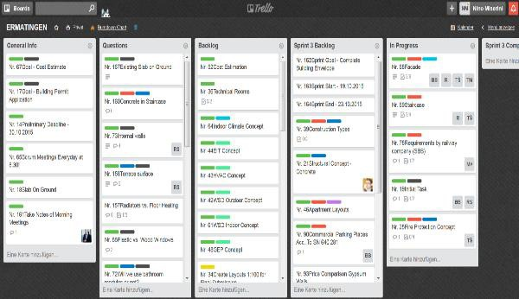 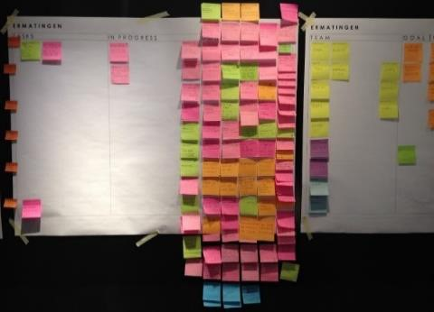

(a) (b)

Figure 3: Screenshot of virtual Kanban board (a) and physical Kanban board (b). *Source: the authors.*

# Results

The results from the implementation of Scrum were evaluated by grading the Daily Scrums, interviewing the Scrum Team, and conducting a critical analysis of the Product Backlog Items.

All Daily Scrums were recorded and systematically analysed using a template with eight questions developed for this study. All questions were graded with marks in the range of 1.0 (not measurable) to 6.0 (excellent). The questions answered at the end of each Daily Scrum, along with their absolute weight for the final evaluation, are summarized in Table 2.

Table 2: Weight of Daily Scrum questions

|  |  |
| --- | --- |
| Question | Absolute weight [%] |
| Q1 - How many participants completed a Task? | 33.3 |
| Q2 - How many participants answered the three core questions? | 33.3 |
| Q3 - How long was the Daily Scrum? | 6.6 |
| Q4 - Took the Daily Scrum place at the same location and time as always? | 6.6 |
| Q5 - Was someone absent, late or left early? | 6.6 |
| Q6 - How many participants talked longer than three minutes? | 3.3 |
| Q7 - How many participants talked less than a minute? | 3.3 |
| Q8 - How many extern participants talked? | 6.6 |

The questions in Table 2 were organized in three parts: Q1, Q2, and Q3 through Q8. The weight was set to reflect 1) the importance of the Items and their associated Tasks, 2) the three core questions of the Daily Scrum (What did I do? What will I do? What are the obstacles?) and 3) general information (How long? Where? When? Who?).

0

,

1

,

5

1

2

,

0

2

,

5

3

0

,

3

,

5

4

,

0

5

,

4

,

0

5

5

5

,

6

0

,

23

24

25

26

27

20

1

2

3

4

5

6

7

8

9

10

12

13

14

15

16

17

18

19

11

21

22

Grade

Daily Scrum

Average grade of Q3 to Q8 [33%]

Average grade of Daily Scrum [100%]

Average grade of Q1 and Q2 [66%]

Figure 4: Weighted evaluation of Daily Scrums

The evaluation of the Daily Scrums is summarized in Figure 4. The performance of the Daily Scrum (dashed line in Figure 5), as represented by the average grade, increased from a 2.5 (very poor) to a 4.3 (satisfactory-good) over the 27 observed Daily Scrums. This was attributed mainly to the improvements related to question Q2, as with time the Development Team got much better in getting a clear understanding of the whole process. They could report on what was done since the last meeting, as well as efficiently planning upcoming work while identifying and articulating the main obstacles in their tasks. The average grades for Q1 deteriorated mostly due to the fact that the Items did not consist of Tasks which could be completed in one or two days of work, making it hard to make improvements in this area. The fluctuation of the dashed line is based on the average grade for Q1 and Q2 (dotted line). The average grade for Q3 to Q8 (solid line) varied strongly from day to day, but it was generally on the upper end of the scale (overall average of 5.2); however, no general improvements were observed.

At the end of week eight, an interview was conducted with the Development Team and the Scrum Master (with a total of eight participants) and questions were graded from 1.0 (low) to five (high). The main purpose of the interview was to get feedback from the Scrum Team regarding their general perception about the Scrum framework and its implementation. The results from those interviews showed that the duration of the Daily Scrum was appropriate; however, the Sprint Planning and Retrospective were slightly too long, and the Sprint Review was slightly short. In addition, the efficiency (i.e. the added value for the design process) of the different Scrum Events was rated by the interview participants. The Daily Scrum received a 3.9, the Sprint Planning and Review each a 3.5 and the Sprint Retrospective a 3.0, all from a scale from1.0 (does not add any value) to 5.0 (does provide a lot of value).

As the Scrum Framework (Figure 1) states who must attend the Scrum Events, the attendance necessity was rated by the Development Team and the Scrum Master as well. The grades ranged from 4.0 (Daily Scrum) to a 4.4 (Sprint Review). In addition, the different team members were asked about their view of Scrum regarding the following criteria:

x Introduction: How was the introduction to Scrum? x Knowledge: What is your personal state of knowledge about Scrum? x Necessity: Do you understand why did you use Scrum in this Project?

x Continuity: Do you know who you can ask if you have questions about Scrum?

x Relevance: Do you like the application of Scrum for the Design Process?

Figure 5 shows that the Introduction and Knowledge about Scrum were low when the project had started. It is worth to mention that all eight interviewed participants would like to continue using Scrum in the Design Process instead of the traditional approach they had used over years of practice. In fact, after only five weeks of experience, the Development Team was convinced that Scrum was more efficient than their previous approaches and methods. Mentioned benefits of Scrum were a higher transparency, better communication and collaboration, better flow of information and faster project development.

Introduction

Knowledge

Necessesity

Continuity

Relevance

Figure 5: Perception from the Development Team and the Scrum Master about the implementation of Scrum for different criteria (1: poor; 5: high)

Another important advantage of using Scrum was that the many meetings enabled the single member to see the point of view of other team members and starts to understand why something was done in a certain way. Thereby, team members improved their knowledge in a field where they were not experts, helping to support the concept of cross-functional teams. The participants also indicated some difficulties when using Scrum, e.g. the missing knowledge at the beginning, no clear project leadership and that a lot of time was needed for voting in the Development Team as the team was hold accountable. Finally, the Kanban board has proven itself to a useful tool for the Development Team to keep track on the development.

Overall, the disadvantages can be addressed to the low knowledge about Scrum at the beginning of the process; the duties and responsibilities of each member were not clear or well defined. Therefore, it is important to not only implement the events, artifacts and roles shown in Table 1, but also to entirely understand them. Due to this reason, more time was needed for the meetings and the voting, as well as the creation of the Product Backlog. The knowledge gained from this process was very valuable and can be reused for future projects as the description of the Items remains the same and only the scope and some Tasks need to be adjusted. Over time, a pre-defined Product Backlog can be created to significantly expedite the time to complete Phase 2 and Phase 3.

# Conclusion and Outlook

As shown in Section 4 and 5, the successful application of Scrum in the construction industry is possible. The paper shows that no significant adjustments are needed to the original Scrum framework given by [9]. The following points should be considered when Scrum is applied in the construction industry:

x Get a good understanding of how Scrum works and get all parties (Development Team, Scrum Master, Product Owner, Stakeholder, Management) involved from the beginning.

x Take enough time to create a clear and comprehensive Product Backlog with Items and Tasks.

x Inspect, update and adapt the Product Backlog Items before every Sprint Planning. x Use Planning Poker for all Items and do it again if changes are made to the Items. x Attend all the Scrum Events (even members of the Development Team working part-time on the project).

x Make decisions (the Product Owner) on a timely manner in every Sprint Review to avoid putting the Development Team on hold.

Constant inspection and adaption of a new Scrum process will evolve with time and further support and fasten the Design process. Our recommendation is not to try to plan every detail of Scrum as you are used to do, but to *just do and adapt* as needed.

Scrum, as described in this paper, can easily be applied in companies which have almost all the in-house expertise needed for the construction of a building. With the proper framework Scrum may also work with some external experts. However, this results in a higher effort for communication and therefore slowing down the process and defeating its purpose.

In addition, we believe that Scrum could also be applied in the construction phase with Daily Scrums on-site as a means of communication between the different companies to reduce waste of time. For example, Daily Scrum could be beneficial to inform construction companies about the work progress and the daily goal (Sprint) of other construction companies also working on site. In this case, no relocation of workers would be needed and the downtime could be reduced. We see great potential of the use of Scrum especially in refurbishment projects, where a daily update about new information of the existing construction could significantly improve the way projects are managed. Similar to the lean approach of the last planer concept [13].

# Acknowledgements

The authors would like to thank SWISS PROPERTY AG, in particular their Head of Technology Management as well as their Design department for their collaboration during this study and for providing information for the case study.

# References

1. Halamzie, F. (2013). Management von Softwareprojekten: klassisch, agil, lean und systemisch. Diplomica Verlag.
2. SIA 112 (2001): Service Model. Swiss Society of Engineers and Architects, Zurich.
3. Owen, R., Koskela, L. J., Henrich, G., & Codinhoto, R. (2006). Is agile project management applicable to construction?. In *Proceedings of the 14th Annual Conference of the International Group for Lean Construction* (pp. 51-66).
4. Cervone, H. F. (2011). Understanding agile project management methods using Scrum. OCLC Systems & Services: International digital library perspectives, 27 (1), 18-22.
5. Highsmith, J. A. (2002). Agile software development ecosystems (Vol. 13). Addison-Wesley Professional.
6. Sutherland, J. (2014). Scrum. A revolutionary approach to building teams, beating deadlines and boosting productivity. Random House Business Books.
7. Fowler, M., & Highsmith, J. (2001). The agile manifesto. Software Development, 9(8), 28-35.
8. Nonaka, I., & Takeuchi, H. (1986). The new new product development game. Harvard business review, 64 (1), 137-146.
9. Sanchez, L.M., & Nagi, R. (2001). A review of agile manufacturing systems. International Journal of Prodcution Research, 39(16), 3561-3600.
10. Schwaber, K., & Sutherland, J. (2013). The definitive guide to Scrum: The rules of the game. Available online at:

http://www.scrumguides.org/docs/scrumguide/v1/scrum-guide-us.pdf [11] Cohn, M. (2005). Agile estimating and planning. Pearson Education.

1. James, M. (2010). Scrum reference card. CollabNet Inc.
2. Ballard, H. G. (2000). The last planner system of production control (Doctoral dissertation, The University of Birmingham).

Artículo 2: Acceptance of an agile methodology in the public sector

Available online at www.sciencedirect.com



# ScienceDirect

Procedia Computer Science 138 (2018) 621–629

CENTERIS - International Conference on ENTERprise Information Systems /

ProjMAN - International Conference on Project MANagement / HCist - International

Conference on Health and Social Care Information Systems and Technologies, CENTERIS/ProjMAN/HCist 2018

Acceptance of an agile methodology in the public sector

Afonso Ribeiro*, Luísa Domingues

*ISCTE-IUL, Av. das Forças Armadas 36, 1649-026 Lisboa, Portugal*

## Abstract

Software development methodologies have been growing up and suffering a maturation during the past years. The older methods, called traditional methods, are gradually being substitute by the new agile practices. Despite that, in the public sector, that evolution is not as clear as in the private sector. The lack of information regarding the usage of these new methods in the public sector take us to the following question: In what conditions, agile methods, are the best solution to software development in the public sector? These types of organizations have a culture and a *modus* *operandi* very different from the private sector, that can make the implementation of these methodologies a challenge. The goal here is to present the process of implementation of a specific agile methodology based in Scrum, in a particular Portuguese public company and test its acceptance.

© 2018 The Authors. Published by Elsevier Ltd.

This is an open access article under the CC BY-NC-ND license (https://creativecommons.org/licenses/by-nc-nd/4.0/)

Selection and peer-review under responsibility of the scientific committee of the CENTERIS - International Conference on ENTERprise Information Systems / ProjMAN - International Conference on Project MANagement / HCist - International Conference on Health and Social Care Information Systems and Technologies.

*Keywords:* *Change Management; Project Management; Agile Methodologies; Public Sector.*

* Corresponding author. Tel.:912135226. *E-mail address:* afpro@iscte-iul.pt

1877-0509 © 2018 The Authors. Published by Elsevier Ltd.

This is an open access article under the CC BY-NC-ND license (<https://creativecommons.org/licenses/by-nc-nd/4.0/>)

Selection and peer-review under responsibility of the scientific committee of the CENTERIS - International Conference on ENTERprise Information Systems / ProjMAN - International Conference on Project MANagement / HCist - International Conference on Health and Social Care Information Systems and Technologies.

10.1016/j.procs.2018.10.083

## 1. Introduction

In order to follow the market changes, the software development methodologies have also adapted, becoming more flexible. Despite of these new methods have been well received by the private sector, in the public this didn’t happen. In the public sector the adoption has been slower and the attention given to the empirical studies that identify and describe the challenges regarding the implementation and execution of these new methods has been scarce [1]. Convoy, in accordance, refers the challenges in the adoption of Agile methods and requires for more investigation regarding the effects of the application of the methodology [2].

The relevance of this paper derives from the premise that is necessary a bigger contribute to the scientific knowledge in this area. The goal is to analyze the acceptance level of a customized agile methodology applied to a Portuguese public company. To accomplish that is intended to explore the current software development practices in the company and the current agile methodologies used in this sector. Then one methodology will be adapted to the current software development, in order to maximize their software development efficiency and minimize the change resistance. To introduce the new methodology, a workshop was presented. In this workshop there were three phases: presentation of the methodology, a practice exercise and an evaluation form. The acceptance will be measured by the form results and the practice exercise was included so the participants could evaluate the methodology as aware as possible.

This paper is composed by four chapters. The first is a literature review regarding the agile methodologies, the second is the company context, the third is a description of the methodology implemented and the fourth are the results of the methodology implementation.

## 2. Literature Review

### 2.1. Agile Methodology

The concept of agile methodology acquired visibility in February of 2001 when the agile software development manifest was published *software* [3]. Despite the principles and practices of the agile software development weren’t completely new, the way they were articulated and integrated in one theoretical framework was [4].

The agile methodologies were created to mitigate the software development traditional methods limitations, like the excess of documentation or the time to market ineffectiveness [5]. Basically, they emerged to respond to the inefficiency off the current software development methods [6].

These methodologies arise in a period where the client exigency regarding the products and services contracted suffer a change. This phenomenon is, among other reasons, consequence of the increase of business competitiveness. This led the clients to appreciate aspects like fastness in the delivery and cost reduction in the software development [7]. Beyond this changes in the clients perceived value in the software development, the suppliers intend to obtain more profit with less resources with the goal of complete more projects in a shorter period of time [8].

### 2.2. Agile methodologies in the public sector

Despite the increased implementation of agile methodologies in the past years, their adoption in the public sector has been slow. This fact is also reflected in the literature, as are scarce the studies regarding the adoption of an agile methodology in the public sector [9]–[11]. Nowadays, the usage of agile methodologies is gaining notoriety in public institutions, however, the attention given to empirical studies describing the challenges of the implementation and execution of agile methodologies in this context are few [1]. The same way, Convoy refers the challenges of adoption of agile practices and request for more research about the effects of their implementation [2]. Besides that, Conforto et al. considers important more research in agile project management and in the use of agile practices in other industries [12]. Thomas and Niederman also refer the importance of more research regarding the implementation of agile methods in different contexts [13].

Public organizations have some characteristics that make the acquisition of software more challenging comparatively with the private organizations. In addition to the existence of legal regulation in the acquisition of projects [14], the technological systems from these types of entities, by rule, are big and complex [15]. The innovation and development speed, usually are also slower than in the private sector [15]. Parker and Bradley refer that organizational culture in the public sector is often very hierarchical with rules and politics with poor flexibility and with formal, communication oriented documentation [16] .

The study done by [17], identifies two challenges in the implementation of agile methodologies. The lack of involvement and participation of the final user in the project and the lack of flexibility to integrate requirements during the project development. Jouko Nuottila and Kirsi Aaltonen in their 2016 article identify seven categories of challenges in the implementation of agile methodologies in the public sector [1]:

* Documentation – Employees miss understood lack of documentation with no documentation;
* Education, experience and dedication – It is necessary to instruct the company with the agile practices;
* Communication and stakeholders involvement – It is important to identify the stakeholders in the beginning of the project and communicate when necessary each of them all the important decisions;
* Roles in project – The methodology change leads to roles changes and that can cause lack of responsibilities when the employees don’t understand their new roles;
* Development team localization – It was identified that teams, in some projects, worked away making the coordination and communication more difficult;
* Legislation – The study identifies some confrontations between the legislation and the principles of agile methodologies. Delivery dates, costs, information confidentiality, etc.
* Architecture complexity of software systems – Due to the complexity of the systems, the study reported some difficulty in the integration of the old systems.

Despite this, [11] reports a case of success in the adoption of the agile practices in the public sector. A study performed by Seville University [18] presents the results of the application of an agile methodology (Scrum, in this case) in a public organization. In this study it was used a planning and estimation technique to the projects and it was verified that the estimations of the projects with this methodology were, in almost all the cases, achieved. Other study by [19] that had has goal evaluate the adoption conditions of an agile methodology in the public sector, concluded that there is a slide preference for agile practices when confronted with.

## 3. Company context

The study was applied in a public Portuguese enterprise. The company is responsible for all information systems of a specific public sector. Their responsibilities are assuring the execution and maintenance of the technological resources and information systems of the correspondent sector, ensuring the management and administration, in articulation with other systems from that sector, and supporting the users. Assuring the information systems adequacy to the needs of the management and operability of the organs, services and organisms of the sector. Prepare strategic proposals of the information systems, taking in account the technological evolution. Prepare, develop and coordinate proposals of investment projects, regarding computer science and services communication to organisms in the sector. And finally, promote information management solutions in this sector.

Regarding a software development, it was identified an absence of a methodology in the company, each sector and team had the freedom to choose the way they wanted to work. Some problems were identified due to the inexistence of a methodology. For example, the dependencies between the projects were compromised because the communication was scarce and the dependencies were not planned and executed in time, leading to delays. The synergies between the project execution and the infrastructures departments are other example of a limitation of the absence of a methodology. Sometimes the lack of preparation and planning lead to an unstable application environment.

There are two types of projects developed by the company, the ones that are accomplished internally and others externally (turnkey). The projects implemented internally have an internal project manager and an internal team. All resources are in the company facilities and close to each other.

The turnkey projects, are developed by an external team. The team receives a specification and the goal is to deliver the product in the agreed date. The communication during the project execution is very scarce and the internal support is not always the best, primarily because the resource that is managing the project from inside has other responsibilities and the project gets to second plan.

## 4. Agile methodology

After the contextualization of the enterprise the goal was to choose a methodology that would mitigate as much as possible the problems identified previously.

It was verified that XP and Scrum are the methodologies most used in general and Scrum, specifically, in the public sector. Furthermore, Scrum is an incremental, iterative and flexible methodology. These kinds of characteristics mitigate the control and management problems identified previously. It capacity to change the requirements at any time of the project, allows the new legislations be added to the project with no friction to the normal operation of it.

The remaining methodologies present some limitations regarding de correction of those problems. Crystal gives too much liberty to the team to decide how they want to work, once again, in non-standardized project management (14). FDD works with features, something that does not show advantages to this case since it does not integrate practices that allow the suppression of existing problems in the organization [20]. DSDM does not approach the monitoring the project topic (14). ASD is more indicated to complex problems and doesn’t give the necessary importance to costs and resources, important aspects in the company project management [20].

With that in mind, it was decided to apply a customized Scrum. The reason why Scrum wasn’t applied has a whole is the change resistance that was identified in chapter 2.3 as one of the major problems in the implementation of agile methodologies in the public sector.

The methodology is defined in three dimensions: roles, information workflow and documentation. In the next subchapters they will be explained in detail.

### 4.1. Roles

It is intended that all those involved in the project know which role and responsibility they have. In this sense, they will be accountable for accomplish the phases and documentation of the methodology. In order to present the roles and responsibilities, it is necessary to identify the stakeholders involved in the project.

Table 1. RACI table for internal type projects Table 2. RACI table for turnkey type projects

|  |  |  |  |  |  |  |  |  |  |  |  |  |  |
| --- | --- | --- | --- | --- | --- | --- | --- | --- | --- | --- | --- | --- | --- |
| **RACI** | **CA** | **C** | **IPM** | **DT** | **RI** |  | **RACI** | **CA** | **C** | **IPM** | **EPM** | **DT** | **RI** |
| **Phases** |  |  |  |  |  | **Phases** |  |  |  |  |  |  |
| **Requirements gathering** | **I** | **C** | **A/R** |  |  | **Requirements gathering** | **I** | **C** | **A** |  |  |  |
| **Sprint planning** | **I** | **I** | **A/R** | **R** | **C** | **Sprint planning** | **I** | **I** | **A** | **R** |  | **C** |
| **Sprint execution** |  |  | **C** | **R** |  | **Sprint execution** |  |  | **C** | **A** | **R** |  |
| **Sprint revision** |  |  | **A** | **R** |  | **Sprint revision** |  |  |  | **A** | **R** |  |
| **Sprint replanting** | **I** | **I** | **A/R** | **R** |  | **Sprint replanting** | **I** | **I** | **A** | **R** |  |  |
| **Project summary** | **I** | **I** | **A** | **C** |  | **Project summary** | **I** | **I** | **A/R** | **C** |  |  |
| **Documents** |  |  |  |  |  | **Documents** |  |  |  |  |  |  |
| **Requirements list** |  |  | **A/R** |  |  | **Requirements list** |  |  | **A/R** | **A/R** |  |  |
| **Progress Report** | **I** | **I** | **A/R** | **C** |  | **Progress Report** | **I** | **I** | **C** | **A** | **R** |  |
| **Project plan** | **I** | **I** | **A/R** |  |  | **Project plan** | **I** | **I** | **A** | **R** |  |  |
| **Project charter** | **I** | **R/A** | **I** |  |  | **Project charter** | **I** | **R/A** | **I** |  |  |  |
| **Change requirement** |  | **R/A** | **R/A** |  |  | **Change requirement** |  | **R/A** | **R/A** |  |  |  |

*A …….: Accountable C …….: Consulted R …….: Responsible I ……..: Informed*

* Development team (DT) – Team of developers that develop the project functionalities;
* Internal project manager (IPM) – Internal manager that control the project and is responsible for the success of the project;
* External project manager (EPM) – External manager that control the development team and is responsible for the well execution of the functionalities;
* Responsible for the infrastructure (RI) – Employee with authority and power to make decisions regarding the infrastructure necessities for the project execution;
* Company administration (CA) – It should be nominated a person accountable for the project.
* Client (C) – It is the entity that that requests the services.

### 4.2. Documentation

Scrum, in accordance with the other agile methodologies, advocates the reduction of documentation compared to that elaborated by traditional methodologies. The goal is to produce only the necessary documentation to develop the project, privileging the technical evolution of the solution. The documentation was based in the PMBOK, project management standard guidelines and in the OpenPM², project management methodology designed by the European Commission.

It is proposed the following documents:

* Requirements list – This document should include all functionalities, bugs, defects, updates, documentation and improvements that the product will have. This document should allow the stakeholders to access the progress of the developments of the projects;
* Progress report – In the end of every sprint, this document should be filled. It intends to centralize the information regarding the state of the project after the end of the sprint. The goal is to understand if the sprint was completed with success or if something wasn’t well done;
* Project plan – The project plan contains all the information of the project. All modifications to the requirements and sprints should be documented in this template. Scope, stakeholders, assumptions and dependencies are information that should also be included in the document, as well as, software development life cycle, deliveries and milestones.

In addition to these documents, depending the adequacy, risks and complexity of the project the following documents should be included:

* Usage support – Depending of the project, if it is pertinent, it should be developed a utilization manual o f the system with the goal of helping the users using the system.
* Technical documentation – The developed code should include comments. This point has special importance when the algorithms are complex and can lead to miss understandings;
* Project Charter – This document should be developed by the client that requests the project. It contains basic information about the project so that the beginning of it could be angelized and some components could be clarified, as well.
* Change requirement – This document has information about the requirement that it is intended to change or add to the project. Changes that are significant, should be asked formally in this document, however, it not mandatory.

### 4.3. Information workflow

The information flow will define how and when the information will be passed, who will receive it and how it will be delivered. There are two information flows, as it happened to the role dimension, one for each type of project (internal and turnkey).

In the Fig 1 there are six phases. The requirements gathering phase is supposed to be develop by the project manager together with the client. It has available project information (scope of the project is assumed done) as input and it generates the requirements, list of documents and the functional analysis (if applicable) as output. Ideally the client should deliver the project charter document. After the requirements list, it’s the sprint planning phase. In this phase, the team and the project manager should work together to construct the project plan document and prioritize the requirements list. The development team is responsible for the execution phase that aims to develop the requirements agreed and defined for that sprint.

Fig 1. Detailed internal project workflow

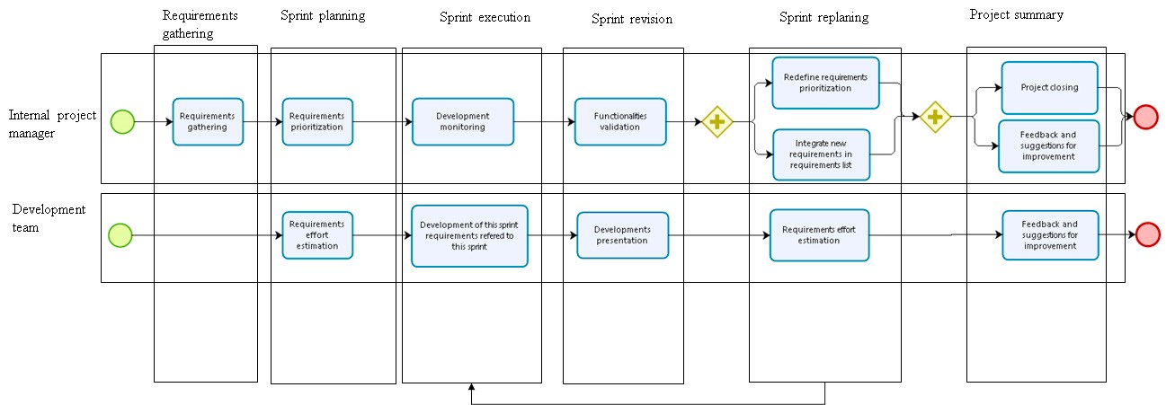

After the execution there should be a sprint meeting where the work done should be revised and the progress report should come as the output. If it is the last iteration, then the next phase is the closing project where the project balance is analyzed and lessons are learned. Otherwise, the next phase is the replanting meeting where it can add or update requirements and sprints.

Fig 2. Detailed turnkey project workflow

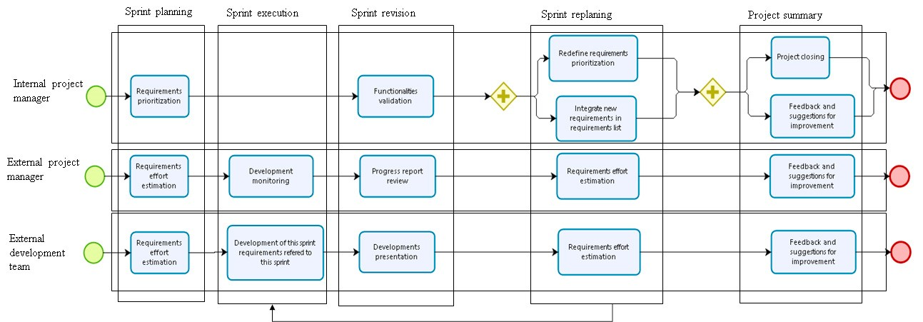

The information flow for the turnkey type of projects is the following:

As it is possible to verify in the Fig 3, to the turnkey type projects the development phases are almost the same as the other type. The differences are the responsibilities, roles and tasks of the stakeholders in the project. In this type of projects there is

## 5. Results

In order to verify the acceptance of these methodology in the public company analyzed, there was a workshop session where the methodology was presented. In the end, they filled an anonymous form with eleven closed questions (all mandatory) and one space for comments. They evaluated the methodology as a whole and each document and practice individually. There were sixteen participants, corresponding to 90 percent of the project managers of the company and covering all departments of it. From that sixteen, eleven answered the quiz, the others didn’t find availability and had to leave. The questions are the following:

K1: Do you consider that there is a need to adopt a software development methodology in this company?

K2: Do you consider that the methodology presented is appropriate to the context of t he company?

K3: Classify the relevance of the following documents regarding software development in the company?

K4: Rate the appropriateness of the following documents to the company project management needs?

K5: Please rate the following documents according to the ease of filling?

K6: Classify the relevance of the following practices /phases in software development in this company?

K7: Classify the appropriateness of the following practices/phases to project management needs in the company?

K8: Do you consider that this methodology benefits the organization?

K9: Do you consider that this methodology makes the development of software in the company more efficient?

K10: Do you consider that this methodology lived up to your expectations?

K11: Would you be willing to use this methodology in the future?

There are two types of questions. The ones whose answer is an ordinal scale with five levels (ascending sort) and the ones whose answer is yes-no-maybe.

The results of the questions are presented in the following table:

Table 3. Acceptance of the methodology results of yes/no/maybe questions

|  |  |  |  |  |  |  |  |  |
| --- | --- | --- | --- | --- | --- | --- | --- | --- |
| Questions | Number of yes replies | Number of maybe replies | Number of no replies | | Percentage of yes replies | | Percentage of maybe replies | Percentage of no replies |
| K1 | 8 | 3 |  | 0 |  | 73% | 27% | 0% |
| K2 | 6 | 3 |  | 2 |  | 55% | 27% | 18% |
| K8 | 6 | 5 |  | 0 |  | 55% | 45% | 0% |
| K9 | 6 | 4 |  | 1 |  | 55% | 36% | 9% |
| K10 | 10 | \ |  | 1 |  | 91% | \ | 9% |
| K11 | 6 | 5 |  | 0 |  | 55% | 45% | 0% |

Fig 3. Practices/phases acceptance of the methodology

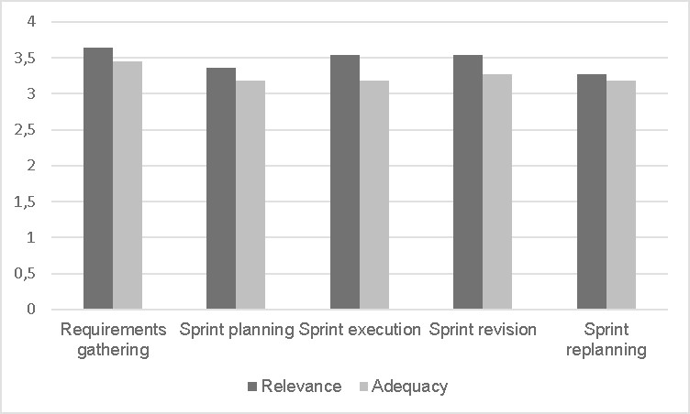

Fig 4. Documents acceptance of the methodology

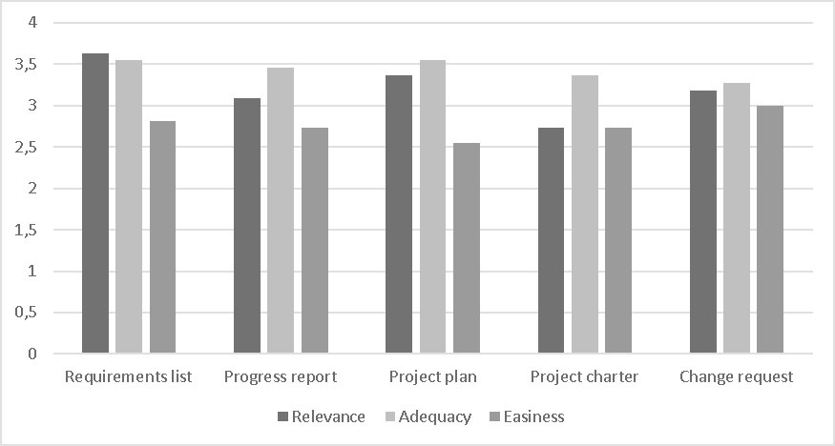

Regarding the documents relevance it was verified that the most relevant is the requirements list followed by the project plan. In congruence with these data are the results of the adequacy of the documents. In this case, the list of requirements and the project plan are also considered the most appropriate. Unlike these, there is the Project charter with an average of 2.7 values in terms of relevance and the change requirement with 3.3 values in adequacy. In the ease of filling question, the change requirement document is highlighted as the easiest to fill.

Regarding the mandatory practices, they were all considered on average to be relevant (3.5 values). The same happens with respect to the adequacy of the methodology to the context of the company whose average is 3.3 values.

Approximately 73% of the participants consider that there is a need to adopt a software development methodology and the rest consider that it may be necessary, with none negative responses. The same happened to the questions regarding benefits, efficiency and willingness to use the methodology all with 55% of positive answers. In these cases, only the efficiency had one negative answer (9%) and 36% answers maybe, while the remaining two factors did not have any negative answer and ended up with 45% answers maybe.

Regarding the adequacy of this methodology to the context of the organization, 55% of the respondents considered that it suits and 27% considered that it might suit. Only 18% (two people) do not consider that it suits the context.

In addition to this, in the form, it was received some qualitative feedback:

* A more explicit test phase should be included;
* The client should be more accountable for some of the phases and decisions;
* The infrastructure should have a more present role in this life cycle;
* It should be possible to include the non-functional, project and technical requirements.

## 6. Conclusions and future work

Despite the identification of some resistance and disagreement regarding this agile methodology, the overall results were positive. No one was unwilling to use this methodology in the future and only two persons don’t think this methodology is appropriate to this context. This is totally understanding since we received some constructive feedback to improve the methodology. Although the change in the public sector companies is considered larger, 73% of the participants in the quiz consider that it is important to have a uniform software development methodology in the company, something that doesn’t exist nowadays. This means that despite the reluctance to change they think the usage of a methodology is very important. The methodology presented also revealed very suitable to the company context with more than 50% of acceptance by the participants in the quiz. Furthermore, the practices and documents showed to be very relevant and suitable, all being, in average, above the 3 values in 4.

In general, and based on the data above quoted, the company evidenced much receptivity regarding the methodology adoption since all the respondents referred that they were willing to use the methodology in the future.

The next steps that complement the study carried out are the inclusion of the feedback that it is considered relevant to software development in the methodology, in order to improve it and the implementation of it in a prototype project. The goal is to analyse, empirically, the success factor of this agile methodology in the public context.

## References

1. J. Nuottila, K. Aaltonen, and J. Kujala (2016) “Challenges of adopting agile methods in a public organization,” *IJISPM-INTERNATIONAL J. Inf. Syst. Proj. Manag.*, vol. 4, no. 3, pp. 65–85.
2. K. Conboy and X. Wang (2007) “Agile practices in use from an innovation assimilation perspective: a multiple case study,”.
3. “What is Agile Software Development? | Agile Alliance.” [Online]. Available: https://www.agilealliance.org/agile101/. [Accessed: 15-Dec2017].
4. L. Williams and A. Cockburn (2003) “Guest Editors’ Introduction: Agile Software Development: It’s About Feedback and Change,” *Computer (Long. Beach. Calif).*, vol. 36, no. 6, pp. 39–43.
5. S. Jalali, C. Wohlin, and L. Angelis (2014) “Investigating the applicability of Agility assessment surveys: A case study,” *J. Syst. Softw.*, vol. 98, pp. 172–190.
6. J. A. Highsmith 2002 *Agile software development ecosystems*, vol. 13. Addison-Wesley Professional.
7. T. Dybå and T. Dingsøyr (2008) “Empirical studies of agile software development: A systematic review,” *Inf. Softw. Technol.*, vol. 50, no. 9–10, pp. 833–859.
8. K. Madadipouy, (2015) “An Examination and Evaluation of Agile Methodologies for Systems Development,” *Australas. J. Comput. Sci.*, vol. 2, no. 1, pp. 1–17.
9. D. Powner (2012) “Software Development: Effective Practices and Federal Challenges in Applying Agile Methods.” United States Government Accountability Office, Washington, DC.
10. A. Kaczorowska (2015) “Traditional and agile project management in public sector and ICT,” in *Computer Science and Information Systems (FedCSIS), 2015 Federated Conference on*, pp. 1521–1531.
11. A. Karaj and J. Little (2013) “Transforming a Public Sector Company: From Stone Age to Agile,” in *Agile Conference (AGILE)*, pp. 74–81.
12. E. C. Conforto (2014) F. Salum, D. C. Amaral, S. L. da Silva, and L. F. M. de Almeida, “Can agile project management be adopted by industries other than software development?,” *Proj. Manag. J.*, vol. 45, no. 3, pp. 21–34.
13. P. Y. Thomas, R, Niederman F, (2017) “Exploring the Role of Agile Approaches for the Management of Projects,".
14. C. Edquist, L. Hommen, and L. Tsipouri, (2000) “Policy implications,” *Public Technol. Procure. Innov.*, pp. 301–311.
15. T. Brown (2001) “Modernisation or failure? IT development projects in the UK public sector,” *Financ. Account. Manag.*, vol. 17, no. 4, pp. 363–381.
16. R. Parker and L. Bradley (2000) “Organisational culture in the public sector: evidence from six organisations,” *Int. J. Public Sect. Manag.*, vol. 13, no. 2, pp. 125–141.
17. N. Wisitpongphan and T. Khampachua (2016) “Agile in public sector: Case study of dairy farm management projects,” *2016 13th Int. Jt. Conf. Comput. Sci. Softw. Eng.*, pp. 1–5.

**Bibliografía**:

# Implementation of Scrum in the Construction Industry

<https://www.sciencedirect.com/science/article/pii/S1877705816339601>

# Acceptance of an agile methodology in the public sector

<https://www.sciencedirect.com/science/article/pii/S1877050918317290>